**Ideation Phase**

**Define the Problem Statements**

|  |  |
| --- | --- |
| Date | 31 October 2025 |
| Team ID | NM2025TMID08347 |
| Project Name | Laptop Request Catalog Item |
| Maximum Marks | 2 Marks |

**Problem Statement Template**

Employees in the organization need a quick and efficient way to request laptops for work. The current process is manual and prone to delays, with no dynamic form behavior to guide users or ensure accurate data collection. To address this, a Service Catalog item needs to be created, allowing users to easily request a laptop, with dynamic fields, clear instructions, and additional functionality like resetting the form if needed. The solution should also ensure all changes are tracked for governance and deployment.

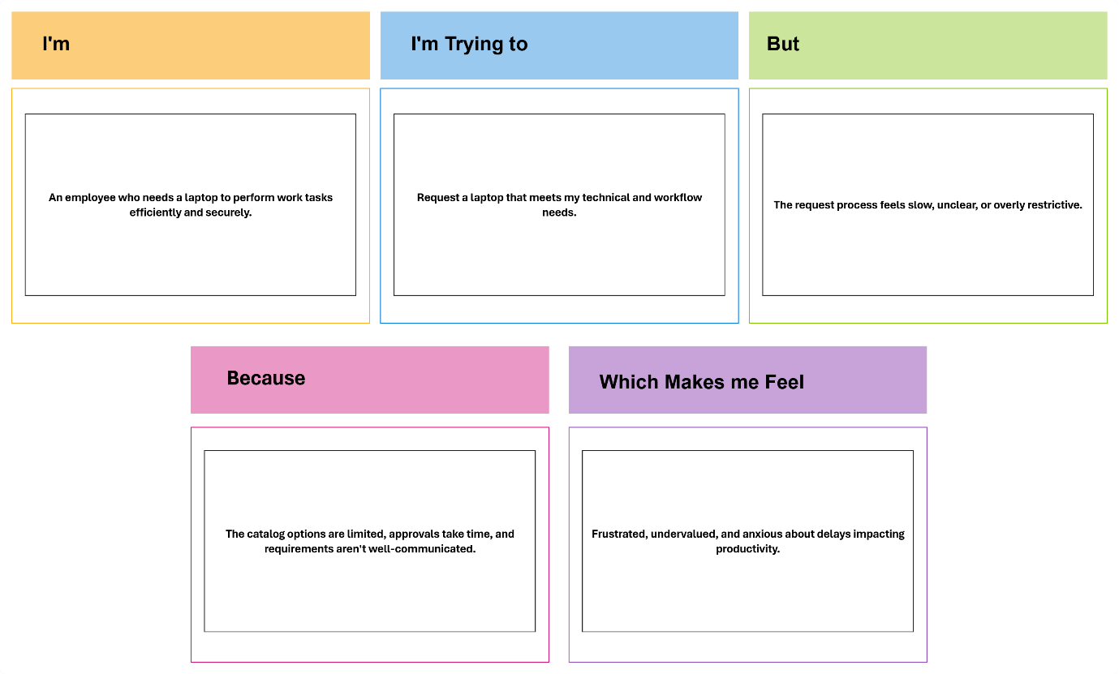

**PROBLEM STATEMENTS:**

